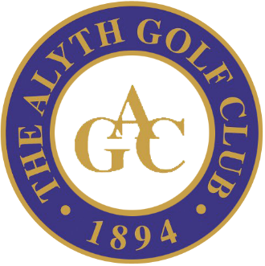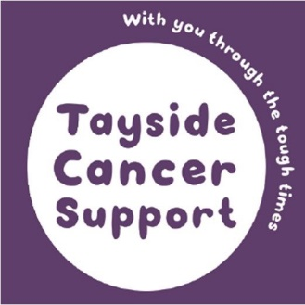

Charity Golf Day - Thursday 17th September 2020
Alyth Golf Club

Tayside Cancer Support invites you to enter a team of four at our Charity Golf Day to be held at Alyth Golf Club on Thursday 17th September. Alyth is one of the finest and most scenic golf courses in the UK.

This, fun but competitive, four ball tournament is open to male, female and mixed teams.
Maximum Handicaps are 24 for gents and 36 for ladies. The names of team members and handicaps will only be required at registration on the day.

Due to ongoing developments with Government guidance in relation to COVID 19 the day will be loosely structured as follows, however this be more fully developed nearer the time. Teams will meet at from 12.30 for refreshments, with a Shotgun Tee Off at 2.00 pm. The day will conclude with a meal, prize giving, auction and raffle. Entry cost per team is £300 which includes the Team, Red Ball and Putting Competitions. There is also the opportunity to enter the Longest Drive, Nearest the Pin and Beat the Pro events. And in addition this year, we have a Hole in One competition where golfers can win a brand new Audi, thanks to sponsorship by John Clark Dundee Audi. Should you wish to enter these additional competitions in advance (to limit the exchange of monies on the day) please add this to your remittance.

Should you have any queries or would like further details, please contact Event Organiser, Linda Swan on 01382 477500 or email: office@taysidecancersupport.org.

If you would like to attend, we would appreciate if you would please complete and return the entry form, along with your cheque made payable to ‘Tayside Cancer Support’ or email if you would like to pay by Bank Transfer.

All the monies raised on the day will be used in Tayside to help those affected by cancer.

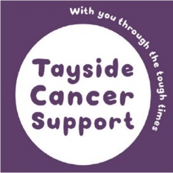

Charity Golf Day - Thursday 17th September 2020
Alyth Golf Club

Golf Entry £300 per Team
Extra Competitions £ 60 per Team
Team/Company Name: ____________________________________________

Address and postcode: _____________________________________________
________________________________________________________

Contact Name : _______________________________________________
Contact Telephone No: _________________________________________

Contact Email Address: _________________________________________

Please make cheques payable to TAYSIDE CANCER SUPPORT or alternatively please email office@taysidecancersupport.org if you would like to pay by Bank Transfer
Return to:
Tayside Cancer Support
St Aidan’s Centre
408 Brook Street
Broughty Ferry, Dundee
DD5 2EB

Email: office@taysidecancersupport.org

